"See I'm doing a new thing" Is. 43:19
12 April 2026
Pastoral Areas - Diocese of Cloyne
Dear Parishioners,
I write to share with you, the people of the Diocese, the outline and fruits of conversations that have taken place in parishes and deaneries over the last year or so.
The process began with my invitation to a group of priests and people to serve as a Diocesan Review Group. The first aim was to get a realistic picture of the current situation by way of religious practice, the number of priests in ministry and the other groups that serve in our parishes. The second goal was to develop a more effective pastoral service to all the parishes in the event of some parishes not having a resident priest.
Our hope has been that our discussion and discernment would have the outcome of development of a new structure in the diocese that would ensure the pastoral care of all.
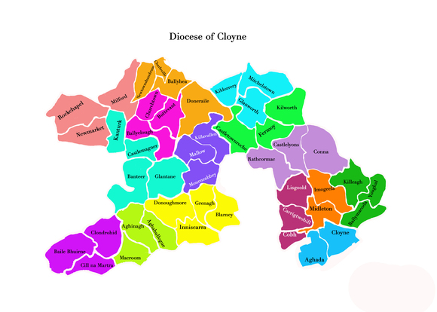Map of Pastoral Areas - Diocese of Cloyne

As a result of our conversations, we now have a draft map of the Diocese in which we can view the agreed pastoral units/areas. In putting these Pastoral Areas in place, I wish to assure you that the individual parishes will retain their autonomy and the structures which are reflected in their liturgy groups, pastoral council and finance council.
I intend to share a fuller account of this work with the priests and pastoral councils. We have yet to agree the timeline for the establishment of these Pastoral Areas. The impact of these adjustments will be reflected in the appointment of priests not just to an individual parish but to share in the pastoral care of the faithful in the Pastoral Area.
The purpose of these adjustments is to support and strengthen one another and our families in the faith. Where two or three are gathered in his name, the Lord Jesus assures us of his presence. This is how the Lord Jesus can be the Way, Truth and Life for all in the daily demand of life.
As we move forward it is important for us not to focus on numbers alone rather it is the quality and depth of our commitment is what matters. The Lord will provide. It is for us who believe to “fan the flame” of faith amongst us.
We are grateful to all who are leading us on this path of renewal and adjustment. It is our sharing in the Synodal journey of the Universal Church under the stewardship of Pope Leo XIV, which calls us to a deeper communion, conscious participation and an intentional sense of mission.
I ask your prayer and support for all in our parishes, people and priests, entrusted with leadership in this sensitive task of adjustment.
With prayerful best wishes,

Yours sincerely,
+ Wm Crean
Most Rev. William Crean, D.D.,
Bishop of Cloyne.

